Ellie Benjamin
Bedrooms, Bathrooms, Kitchens, and Beyond: The Global Histories of Everyday Goods

Overview and Purpose:
Trade has long played a crucial role in many nations’ contributions to the fields of medicine, art, and wellness. For centuries, Americans have re-appropriated the goods native to other peoples and lands abroad. However, it can be easy for Americans today to take for granted all of the global influences that fuel their everyday lives. The global development of different natural resources helps countless individuals in the U.S. remain healthy and happy on a daily basis. While countless Americans regularly consume goods with global roots, the average American does not spend much time thinking about the global origins of their favorite foods or trusted cosmetics. For this reason, it is crucial that Americans are educated about these intercultural connections from a very young age.
This lesson should push students to consider the global influences of that which they might otherwise assume is unique or native to the United States. Students might have established certain goods as ‘American.’ These associations might come from some goods’ use during American holidays like Halloween or national holidays like Thanksgiving, or perhaps due to the communities (such as students’ neighborhoods or schools) with which they traditionally use certain goods. The lesson should help students grasp the role that these global historical connections play in their everyday routines, whether in their dress or hygienic care at home. The fact that so many of the goods and materials discussed in this lesson can likely be found in a student’s home is testimony to the worldliness of the ordinary. In viewing the international links that made the localization of the goods mentioned here possible, students must separate that which is truly international from that which is native to the US, and can consider which internationally-linked items are used in American practices. Certainly, there are uniquely American twists on the commercialization, packaging, and recipes of international goods. One example of this is a Pumpkin Spice Latte from Starbucks, which includes non-indigenous coffee beans, but pairs them with pumpkins, an ingredient famously native to New England. Ultimately, this lesson should allow students to more substantively and readily connect with peoples from international cultures.

Performance Objectives
● Push students to put into historical context the items that appear in their everyday lives.
● Have students think about how international trade has fundamentally shaped the goods (and the practices associated with those goods) that might otherwise be dubbed ‘American.’

Time
Note: the parts constituting this lesson can be carried out in any order
- Parts I and III in one class period
- Part II in a second class period

Materials Needed
Note: in the below list, “n” represents the number of students in the teacher’s class
- Part I
  - N/3 opaque colored papers
    - n/3 with “coffee” and good’s specifics
    - n/3 with “gum arabic” and “”
    - n/3 with “bananas” and “”
  - 10 sets of pre-set questions
  - At least 2 computers, at best n computers
  - Whiteboard (or chalkboard or Smart Board) and dry erase markers/chalk
- Part II
  - At least 2 computers, at best n computers
  - Whiteboard and dry erase markers
- Part III
  - N sheets of white printer paper
  - N packs of colored pencils or black or blue pens or pencils
  - N paper folders
  - At least 2 computers, at best n computers
  - Whiteboard and dry erase markers

Part I – Kitchen
- Divide students into groups of three. Because this activity will involve goods that the students might consume every day, it is easy for a student to spoil for a close friend what good they are referencing (i.e. by saying “this is what you had for dessert yesterday”). For this reason, pay careful attention that no group contains two or more close friends so that this activity can be as challenging as it is intended to be. The challenge of honestly guessing the good and being surprised when given the correct answer is what should stick with the students after this lesson and help them to remember what they learned.
- If possible, arrange individual desks or chairs into triangular formations with students facing their fellow group members.
- The teacher should explain that they are giving each student a secret term and accompanying description. Students will receive the paper face-down and keep it that way until instructed to flip it over and look at their term/description individually. Each student in each group should receive one of the three terms. Note: paper color needn’t correspond with item type.
- Have students flip over their own papers. Note: if the teacher notices that students are looking at the terms of other classmates, whether in their group or not, use one of the back-up terms below (like mocha).
- Once the teacher has given students a few minutes to read over their information, hand each group a paper that reads as follows.…
  - Questions to Ask (required unless starred)
    - Where was this item originally harvested?
    - What was this good initially used for?
    - (For gum arabic only) In what foods is this good found?
    - What is this item used for today, aside from foods and/or drinks?
    - Which items became more popular because of this item’s availability?
    - Which items became more useful because of this item’s availability/adaptation for human use?
    - *Where do you most often find this item? (I.e. in your pantry at home, at the school cafeteria, at an upscale restaurant?)
    - *On what occasions do you consume this item?
- From looking over their own paper and thinking about their good’s information in relation to the questions, students should understand how to answer the questions about their own good from fellow group members. In doing so students should also understand that the answers to these questions are not what they might expect, and, in turn, that being imaginative in asking others questions will be helpful.
- Give each student in every group ten minutes to answer questions about their item and see if each group can guess their item. Once each ten minute period has elapsed, have each student tell their fellow group members what their item was. Repeat twice to accommodate for all students.
- Have each group gather around one computer and have each student take a turn enter into the IOWH website map section’s keyword search the name of her own item. Have students discuss the above list of questions in relation to one another’s goods. Students can take notes, but needn’t do so.
- Give each student a list of the below questions. These questions will relate each student’s thoughts on their own item to the website’s presentations about the items.
  - How far is this item’s place of origin from the U.S.? From where you thought it originated?
  - Does the way in which the item is used today, i.e. as an ingredient in foods sold at supermarkets, make it seem ‘all-American’ to you?
  - What does the way in which Americans appropriated this item mean about globalization? About trade relations established diplomatically?
- To evaluate students on their comprehension of this lesson, ask that each group prepares a skit in which one person is a customer and two people are employees at a grocery store run by food historians. The skits should be no longer than five minutes and each group member should verbally participate. Ideally, this skit should be done in the same class period as the rest of this part of the lesson so that the relevant information is fresh in students’ minds.
- Students can determine the structure of the skit, but it must include examples of groceries containing gum arabic and coffee. In it, students should ask and answer questions about the changing uses of these ingredients.
- Since all groups have the same assignment, students are encouraged to find unique facts about the relevant goods and items containing them to make their skits original.
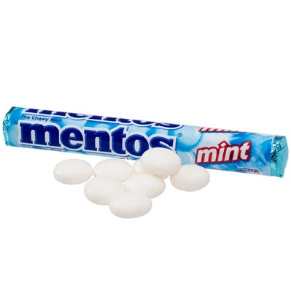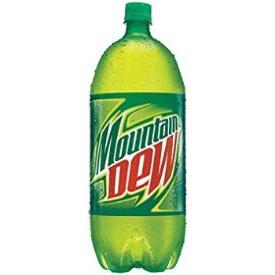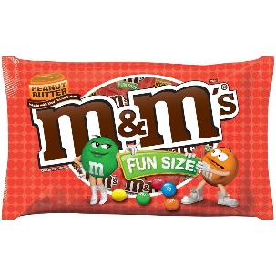
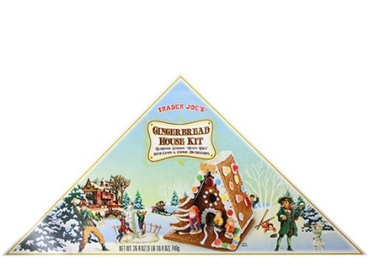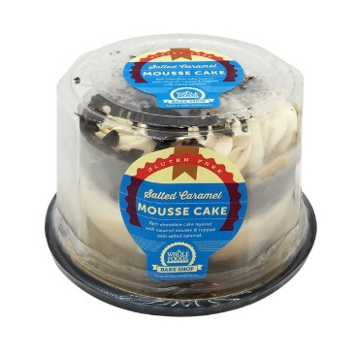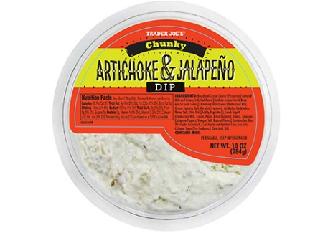

Below is a breakdown of facts about the different goods, categorized by answers to the first set of questions.
- Gum arabic (also known as gum acacia)
  - Map: Northeast Africa, Medieval Era; Northeast Africa, 20th Century and Globalization
  - Origin: Taken from two sub-Saharan species of the acacia tree. Used to be used for viscosity control in inks. It has been harvested since ancient times. Ancient Egyptians used it to mummify dead bodies.
  - Today:
    - Used mostly in the food industry as a stabilizer, used otherwise in pharmaceutical preparations, inks, chewing gum, cosmetics, glue, shoe polish, lick-able adhesives on backs of postage stamps, carbonated soft drinks, fireworks, pottery pigments, water colors, wax polishes, and liquid gum.
      - It binds pigment in watercolors to paper once all water has evaporated.
      - Modern medicines don't separate into their different ingredients because of gum Arabic.
      - Newspaper ink sticks better to paper because of gum arabic.
    - It is also used for dressing fabrics to give luster to silk and crepe and for thickening colors and mordant (dye fixatives) in printing calico-cotton fabrics.
    - Used in some photography to bind pigment-producing chemicals to paper.

    - It is edible for humans, though it acts like glue and holds together different compounds.
      - As a stabilizer, it is a chemical compound added to thicken foods and hold together ingredients that do not normally mix well.
      - Gum arabic is also used in certain types of photography to bind the pigment-producing chemicals to paper
    - Found from Sahel region of Africa to the Middle East and West India
      - Today, the largest producer of gum Arabic in the world is the Sudan.
  - Images: mint Mentos, Mountain Dew, Peanut Butter M & M’s, Trader Joe’s gingerbread house kit, Whole Foods salted caramel mousse cake, Trader Joe’s artichoke & jalapeño dip
- Coffee
  - Map: East of China, First Global Era
  - Origin: Originates from Yemen – has been grown there since the Middle Ages. Porcelain and tea and coffee became popular at same time as the drinks tasted better when drunk from porcelain. Initially, coffee-drinking was a treat for the wealthy, but came to Ottoman court in 1530s. This arrival sparked a debate on coffee (some thought to drink it was against Islamic law, while others thought it was harmless and healthy). Around that time, the first book on coffee was published by an Ottoman legal scholar. The book was called The Argument in Favor of the Legitimate Use of Coffee.
  - Trade: Coffee traveled to Paris in 1670, where it became fashionable for middle and upper classes. By 1700, coffee was popular in most of Western Europe. The Dutch East India Company, recognizing coffee’s popularity, planted coffee in Java, and, from 1715-1735, coffee production there increased from 2000 pounds to six million pounds sterling.
  - Legacy: When Dutch, Indian, and English traders bought coffee from Yemeni Mocha and Jiddah, they traded spices, fabrics, and Chinese porcelain in return. In the New World,
American and Dutch colonists brought their taste for coffee with them. In North America, coffeehouses became popular, while the New World also became a coffee producer. France planted coffee in their Caribbean colony of Martinique, and it soon spread to Latin America.
Images: coffee from Starbucks
- Bananas
  - Map: Papua New Guinea, Ancient Era; Indonesia, Classical Era; Zimbabwe, Medieval Era
  - Origin: Comes from a wild tropical plant with many seeds. Archaeological evidence in New Guinea hints that bananas were first cultivated by people during 8000 BCE or 5000 BCE. Likely also cultivated elsewhere in Southeast Asia. Traveled to India and China by 1000 CE. Maybe reached Africa around 1000 BCE. Word origin evidence in Madagascar indicates potential banana cultivation in Africa after 1000 BCE. Known along major Indian Ocean sea routes by the 600s (including East Africa, potentially Arabia and parts of Southwest Asia).
    - With the spread of Islam and its contact along the land and water routes, bananas spread across the Mediterranean. By the 900s it was grown in Palestine and Egypt. From North Africa it moved to Muslim Spain and West Africa. Muslims probably brought bananas to East Africa and Madagascar, though they may have reached that far earlier through links with the Indian Ocean trade. The word “banana” is linked to the spread of Islam – in classical Arabic, the word means “fingers of the hand.” In present Arabic-speaking countries, it is called mawz. Historians of food believe that the name ‘banana’ was attributed to the fruit in West Africa, where Arabic arrived with Islam’s spread.
    - Although bananas could not be grown in Europe, Europeans who came to Spain may have had tasted them there. Later, in the 1500s, the Portuguese carried the banana to the New World, where it has been grown since the 1500s.
  - Uses: Spread in China as a crop and a food during the Classical Era. During Classical Era, may also have been known in some of the Middle East.
  - Today: The bananas we know, sweet or green, have tiny seeds. Cultivated by cutting and planting a shoot instead of seeds. It is grown as varieties that can be cooked as a vegetable- (plantain) or peeled and eaten ripe and sweet. These types of bananas are now grown worldwide.
- If students are unfamiliar with these goods, the following are other examples of typical American kitchen goods with Indian Ocean ties.
  - Foods
    - Chocolate – Northwestern Africa, First Global Era
    - Rice – China, Ancient Era
    - Ketchup – north of Indonesia, Industrial and Imperial Era
    - Mocha – Yemen, First Global Era
    - Vanilla – Madagascar, First Global Era
  - Spices
    - Pepper – Portugal, First Global Era
    - Cloves, nutmeg, and mace – Papua New Guinea, First Global Era

Part II – Bathroom
- Project or post enlarged images of the below products onto the board. Name each item. From left to right, these items are a Clinique face mask (sold at Sephora, Macy’s, Nordstrom), Cover FX Blotting Powder (sold at Sephora), Tom Ford Shanghai Lily perfume (sold at Sephora, Saks Fifth Avenue), a bottle of Frankincense essential oil (Bed Bath and Beyond), Tarte Finishing Powder (Sephora), Face Stockholm eye shadow (Anthropologie).
- Explain to students that this section of the lesson will focus on common bathroom items. Ask students to give a show of hands to indicate which of the aforementioned cosmetic items contains an ingredient crucial to Indian Ocean trade. Read the item names one by one and have students close their eyes and put their heads on the desk for this activity to get an accurate representation of students’ guesses. Make the last option all of the above items. Tally the votes on the board.
- Explain the use of each item to the students. In doing so, emphasize, where applicable, the role of an Indian Ocean-area good in the given item, and explain how each contains a good important to Indian Ocean trade. Not all items mention a specific use for the given good.
  - Face mask – detoxifies, exfoliates the face. Tested by dermatologists and tested for allergens. The clay removes pollutants and impurities.
  - Blotting powder – absorbs oil from the skin and minimizes shine. Makes skin appear matte. The clay absorbs oil.
  - Perfume – is meant to smell nice and remind those who use it of the Silk Road.
  - Essential oil – known to calm and soothe. Smells fresh and woody. Good for skin and body care as an ingredient. Nurtures and protects. Should be diluted for human use.
  - Setting powder – locks makeup in place, reduces appearance of imperfections, makes skin look matte and replenished, minimizes appearance of pores.
  - Eye shadow – paints the eyelids.
- Ask students what their thoughts are now that they know that such seemingly foreign goods are still used and are sold nearby and nationwide.
- If students do not independently realize the irony of Indian Ocean trade history coinciding with their everyday lives, ask them if this coincidence surprised them.
- Next, students will have a debate to extend these items’ importance into the present; students will debate about which item has been more historically influential.
- Divide the class into two and assign one team the task of defending frankincense for this title, and the other kaolin clay. Move chairs or desks so that there is a space in the middle of the classroom and so that each team can speak confidentially amongst themselves.
- If possible, give each enough computers with the IOWH website pulled up so that no more than two people are assigned to one computer. Allow 30 minutes for students to conduct research using the website. Students can also do research comparing and contrasting the two goods. If the students need an example of an argument to make in order to get started, the following is an example.
  - Kaolin clay is more historically influential historical than frankincense because it has been variably useful for a variety of consumers; today, for face masks, and hundreds of years ago, for making porcelain. The good was not exclusive to someone who wears cosmetics, but could serve anyone, as everyone needs dishes in order to eat.
- Give students five minutes to debate. Ask that everyone speaks at least once, whether or not everyone reads aloud a fact from the IOWH website.
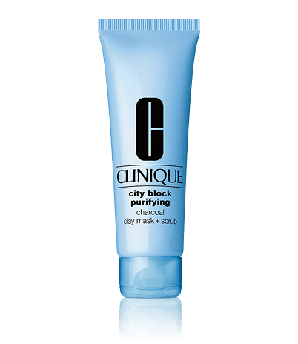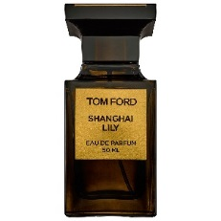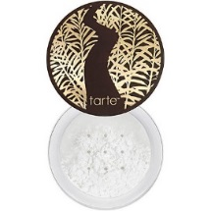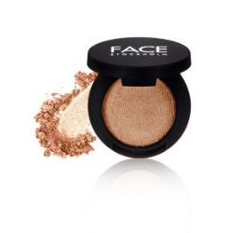
Below are summaries that the teacher can use to fact-check the students’ information on the goods as taken from the IOWH website.

- Kaolin clay
  - Map: Eastern China, Medieval Era
  - Today: face mask
  - Origin: Jiangxi Province in Southeastern China, 7th century CE. Mined from a hill. In 7th and 8th centuries, this rare clay (initially a rock, but then broken down into clay) was mixed by the Chinese with other ingredients, then formed, fired, and glazed to make white porcelain or ‘china’ – then unique to the country. Porcelain was only made in China until the 18th century, when clay like kaolin was found in England, and, later on, in many other places.
  - Today: used to smooth skin and to create dishes off of which people can eat.
  - Images: mask, blotting powder, setting powder
- Frankincense
  - Map: Southern Oman, Classical Era
  - Today: religious rituals i.e. in churches
  - Origin: a type of incense burned for its aroma. Key for religious rituals around Arabian Peninsula, the Mediterranean, and the Near East. Used also as insect repellant, medicine, and embalming of ancient Egyptian mummies. Frankincense comes from the dried sap of trees grown only in Southern Arabia, Ethiopia, and Somalia.
  - During the Classical Era, frankincense was transported by Arab merchants through deserts in the Arabian Peninsula atop camel caravans along the Incense Road, which ended at Gaza. From there, frankincense was shipped across the Roman Empire and to Asia. The abundance of the valuable frankincense in southern Arabia made Roman geographers term the region “Arabia Felix” (lucky Arabia), a reflection of their understanding of the region as immensely wealthy. Indeed, during the Ancient Era, the resin was valued more than gold.
  - Images: Tom Ford perfume, essential oil
- Other examples
  - Gutta percha rubber – Indonesia, Industrial and Imperial Era
  - Combs – Egypt, Ancient Era
  - Porcelain – Tanzania, Medieval Era
  - Incense burner – Oman, Medieval Era
Part III – Clothing
- Have each student sit at a separate desk. If students sit at tables together, have students prop up folders at the front of their desks. Make sure that students’ desks are spaced apart evenly so that each can conduct the assignment privately. Then, give each student a sheet of blank printer paper and a set of colored pencils, or otherwise a blue or black pen or a pencil.
- Ask students to fold paper twice to create four squares marked by creases.
- The teacher should ask students to close their eyes or to look down and then tell the students that they are going to tell them a series of four phrases. They should ask them that, after they say each phrase aloud, the students pay attention to the images and words that pop into their mind immediately after hearing this phrase and write down these ideas and images. Once directions are established and students are ready with writing utensils in hand, read the below phrases, one by one, instructing students to focus on their own wardrobe, in particular, for each prompt.
- Allow a timed three minutes for each phrase in which students can think and put their ideas onto paper. Give a 30 second break between each three minute period. Once all four three-minute periods are elapsed, collect students’ writing utensils and ask that they put away their folders.
  - Me (meaning the student) at a nice family gathering
  - Me enjoying my favorite hobby
  - Me on the weekend
  - Me at school
- Ask students to give a show of hands to indicate which of the following statements apply to any of their drawings. While students silently raise hands to answer ‘yes’ to a question, tally up the ‘yeses’ on the board alongside a keyword marking each question.
  - My drawing includes a pair of jeans.
  - My drawing includes a piece of athletic apparel (i.e. sneakers, an NBA t-shirt).
  - In my drawing, I am wearing something made of cotton.
  - My drawing includes a t-shirt of some sort.
  - My drawing includes someone wearing khakis.
- Show students the total tallies. Hand out papers to each student with the following questions on them. Give the students a few minutes to jot down some quick answers.
  - Do you think denim has always been a fashion statement?
  - Where do you think most athletic apparel production is done today?
  - Where do you think the first t-shirt was made?
  - Do you think khakis were probably first worn by Americans?
- The teacher will inform students that, next, they will ask them to draw conclusions between their use of as well as the origins of clothing and the reality of such clothing’s production.
- Divide the class by counting off students into groups of three. Have each group sit with a computer with the IOWH website pre-loaded.
- Have students compare their answers to the questionnaire with those on the website and those of their group.
- To evaluate students’ understanding of this portion of the lesson, allow students to choose one of the following prompts to address in a one-page single-spaced response paper. In the directions for the paper, ask that students address both dungarees and athletic equipment and tie in cited information from the IOWH website in their response either on the material’s place of origin, original use, legacy, or use today.
  - What are some similarities between the uses of these materials in history and their uses today among your classmates?
  - What are some social implications of the global demand for these products?
- Before concluding the class and after giving students this assignment, give students some facts and figures not provided by the IOWH website regarding the production of athletic apparel and dungarees in the Indian Ocean area today. To engage students so that they use these facts in their assignment and so that they perhaps also conduct their own research, you can share with them the below figures, found on the websites of the respective companies.
  - Sportswear brands still heavily tied to the Indian Ocean area
    - Yeezys – manufactured in China
    - Nike – most of their factories are in Indonesia, China, Taiwan, India, Thailand, Vietnam, Pakistan, Philippines, and Malaysia
    - Adidas – of Indian Ocean area countries, has suppliers in Cambodia, China, Egypt, India, Indonesia, Japan, Jordan, South Korea, Malaysia, Myanmar, Pakistan, Philippines, Singapore, Taiwan, Thailand, Turkey, Vietnam.
    - Puma – has 124 factories total, 117 of which are in Asia (Bangladesh, Cambodia, China, India, Indonesia, South Korea, Malaysia, Pakistan, Philippines, Taiwan, Vietnam).
    - Under Armour – of their vendors, a majority are in China (30) and Vietnam (30).

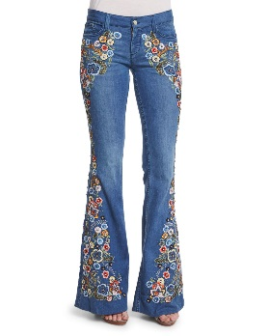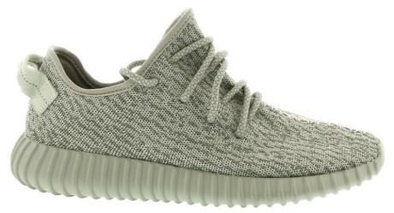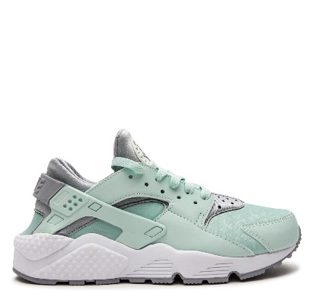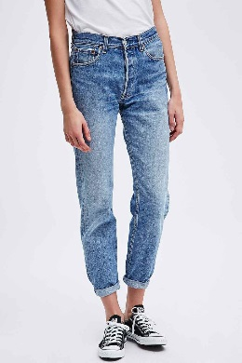

Above are images that you can enlarge and print out and put up on the board to show students how sportswear and dungarees have been adapted over time to remain on-trend for targeted audiences, useful, and desirable. These images should help bring this lesson into the present for students.
Below is some of the crucial information that the students should identify from the website. The teacher should have this core information in mind when assessing students on their exploration of the IOWH website and comprehension of the activity as a whole.
- Dungarees
  - Map: India, First Global Area
  - Origin:
    - Worn for work.
    - The word ‘dungaree’ entered the English language in 1696 but comes from a Hindi word for a coarse, sturdy cloth. The thick cotton fabric was sold in Bombay near the Dongari Killa fort. This cloth was initially made into pants in India.
    - Worn by Portuguese sailors (they became a sailor’s uniform), who wore them with wide, straight, or bell-bottom legs. This way, sailors could quickly roll them up to swab the decks or remove them if the sailors had fallen overboard.
    - Dyed indigo blue.
    - Used in US and Australia by farmhands, herders, cowboys, and miners, from where they entered the clothing market.
  - Today: A global fashion item. Parallel in that they were once a uniform for practical reasons and today are a uniform for relatively the same.
  - Legacy: Today, many of the world’s jeans are made in sewing factories by the Indian Ocean, close to where they originated.
  - Images: American designer bell-bottom jeans; Levi’s jeans
- Athletic shoes and equipment
  - Map: Indonesia, 20th Century and Globalization
  - Today: Sportswear and casual wear
    - Sport shoes, clothes, or bags are almost always made by countries along the Indian Ocean.
  - Legacy:
    - Several major sports outfitting corporations, the world's top suppliers of athletic apparel, have factories in over 160 countries and employ hundreds of thousands of people, especially near the Indian Ocean.
    - Items like shoes, soccer balls and athletic apparel are made in factories by people in countries like China, India, Indonesia, Malaysia, South Africa, and Thailand, then shipped all over. Some of these big corporations have been the objects of protests against globalization, unfair employee treatment, child labor use, payment below minimum wage for long work hours i.e. in Vietnam and Pakistan.
    - Involved companies’ simultaneous unethical employment of globalization to mistreat employees and need for positive public relations has made them begin to pay for their wrongs. This has manifested in the partaking of programs encouraging activity in sports, whether through equipment donation or financial donation to athletic programs in poor regions, as well as efforts to make manufacturing plants more environmentally friendly.
Additional examples
- Clothing and accessories
    - Cashmere – India, Industrial and Imperial Era
    - Gold – Mozambique, First Global Era
    - Indigo – India, Classical Era
    - Cotton – India, Ancient Era
    - T-shirts – Malaysia, 20th Century and Globalization
    - Khakis – India, Industrial and Imperial Era
  - Homeware
    - Ikat patterns – Yemen, Medieval Era
    - Persian carpets – Iran, First Global Era
    - Entertainment electronics – Malaysia, 20th Century and Globalization
    - Paper – China, Medieval Era

